Assignment-8

Submitted By:

Akriti Kumari (Roll No: 120101006)

Vrinda Kochar (Roll No: 120101085)

Answer 1

1. Immediate-Addressing Mode: In this form of addressing operand value is present in the instruction. The number will be stored in twos complement form where the leftmost bit of the operand field is used as a sign bit.

### Example:

Operand =A

**Instruction**

C:\Users\hp\Desktop\archi img\img1.jpg

2. Direct Addressing Mode: In this form of addressing the address field contains the effective address of the operand. It requires only one memory reference.

### Example:

EA=A

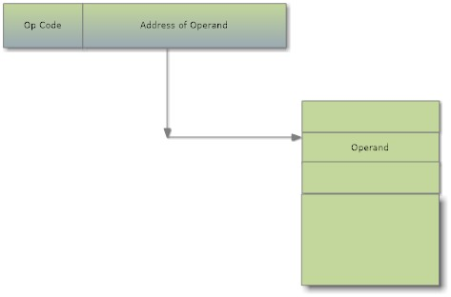

**Direct Addressing Mode**

3. Indirect Addressing Mode : In the Indirect mode of addressing ,the address field refer to the address of a word in the memory ,which in-turn contain the address of the operand i.e the instruction execution requires two memory references to fetch the operand: one to get its address and a second to get its value.

# Example:

EA = (A) 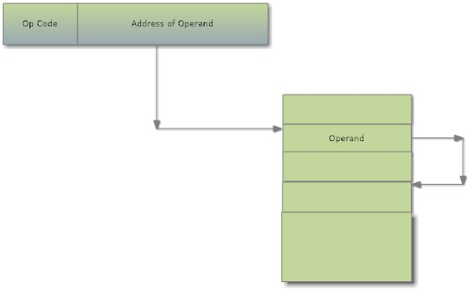

**Indirect-Addressing Mode**

4. Register-Direct Addressing Mode: the address field refers to a register rather than a main memory address. If the content of a register address field in an instruction 5, then register R5 is the intended address, and the operand value is contained in R5.

# Example:

EA=R

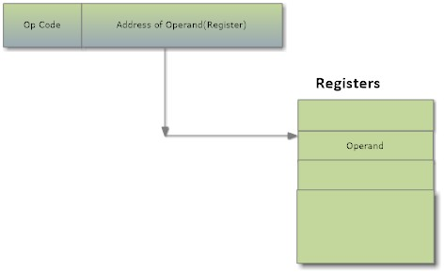

5. Register Indirect Mode: In the Indirect mode of addressing ,the address field refer to the address of a word in the Register ,which in-turn contain the address of the operand i.e the instruction execution requires two memory references to fetch the operand: one to get its address and a second to get its value from the memory.

EA = (R)

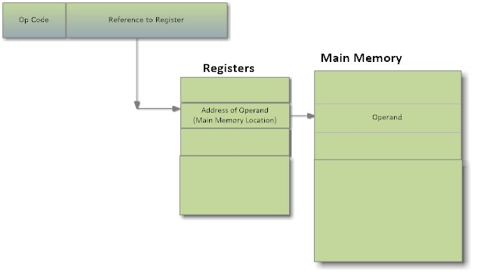

Answer 2

DISPLACEMENT ADDRESSING MODE

Displacement addressing requires that the instruction have two address fields: at-least one of which is explicit, the other address field, or an implicit reference based on op-code, refer to a register whose contents are added to A to produce the effective address.

EA=A+(R)

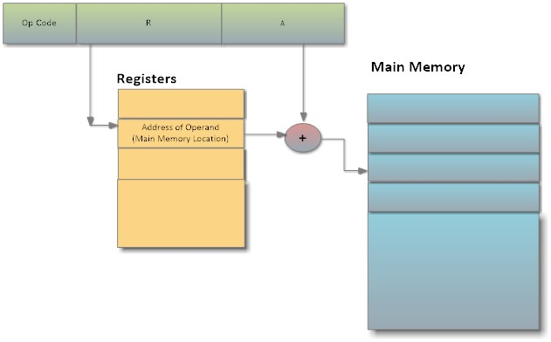

The various variations of the Displacement Addressing Mode are:

1. Relative Addressing

It is also called PC-Relative Addressing; the implicitly referenced register is the Program Counter (PC). That is, the next instruction address is added to the address field to produce the EA. Typically, the address field is treated as a two’s complement number for this operation. Thus, the effective address is a displacement relative to the address of the instruction.

EA = A + (PC)

1. Base Register Addressing

The referenced register contains a main memory address, and the address field contains a displacement (usually an unsigned integer representation) from that address. The register reference may be explicit or implicit.

Example: Segment registers in 8086 processor

1. Indexed Addressing

The address field references a main memory address, and the referenced register contains a positive displacement from that address.

EA = A+R

Example: Used for accessing arrays; EA =A+R; R++;

Answer 3

1. ADDI 75

EA = MDR

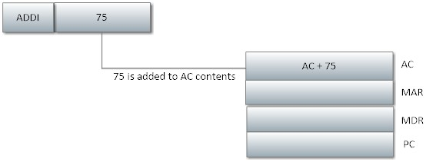

1. ADD 00 75

EA = (7500)16

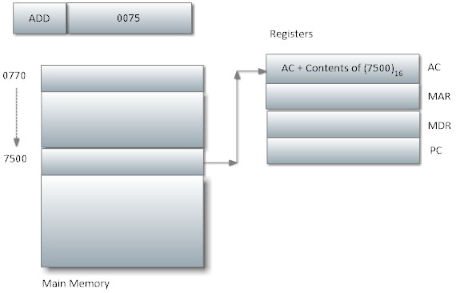

1. ADDI 00 80

EA = (FF70)16

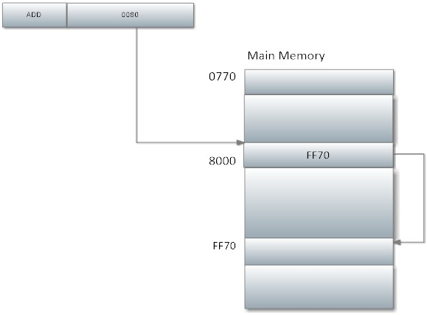

1. ADDX 50 80

EA = (0060)16

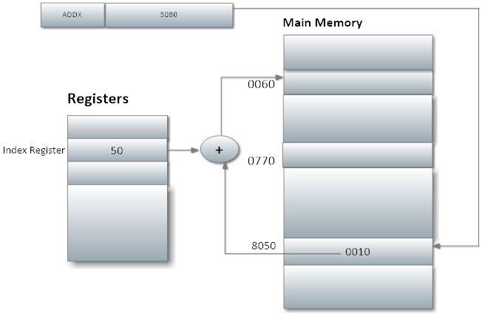

1. ADDR FF 80

EA = (0020)16 + PC

